Activity:

1. My sister ___IS_____ beautiful

2. My brother and I ____are in the basketball team

3. My cat ____IS_____ in the garden

4. My friends ___ARE_____in the party

5. My teacher ____IS_____ very intelligent

6. Thalía __IS___ a famous Mexican singer

7. Hugo and Paco ___ARE___ brothers

8. The restaurant ____IS______closed

* Excepción: Usamos ARE para referirnos a 3cera persona en plural.

Presentations.

Family member presentations.

AM (I), IS( SHE, HE, IT), ARE(WE,THEY, YOU)

W - Questions

<https://www.youtube.com/watch?v=rQbmi96h9-4>

AFIRMATIVA

PRONOMBRE + VERBO TO BE + COMPLEMENTO

I AM VANESSA

**PRONOMBRES**

I — AM —----------------------------------------> 1RA PERSONA

you + we + they + You: ARE —--------------> 2DA PERSONA

It + he + she: IS —-----------------------------> 3RA PERSONA

NEGATIVA

PRONOMBRE + VERBO TO BE + NOT + COMPLEMENTO

I AM NOT VANESSA

INTERROGATIVA

VERBO TO BE + PRONOMBRE + COMPLEMENTO

AM I VANESSA ?

I am Xavier, I´m 35 years old, I´m from Peru, I am studying programmation full stack, I´m a respectful and friendly person. I like to play and watch football on the tv and I like to listen to music. My favorite color is blue. My father´s name is Pedro, he likes to go to the gym, we are very joined, we have pets, his name are Celia and Tanos.

**ADJETIVOS POSESIVOS**

my mi, mis —---------------------> I

your tu, tus (de tú); —---------- > you

Yours su, sus (de ustedes) _______ >You

his su, sus (de él) —--------------> He

her su, sus (de ella) _________ > She

its su, sus (de él o ella, para cosas) _______> It

our nuestro, nuestra, nuestros, nuestras __________> We

their su, sus (de ellos o ellas) __________> They

MY CAR : Mi carro.

Your car: Tu carro.

Yours cars: Sus carros.

His car: Su carro (De él)

Her car: Su carro (De ella)

Its name: Su nombre (De eso)

Our cars: Nuestros carros.

Their car: Su carro ( De ellos)

ESTRUCTURA PARA 3CERA PERSONA

PRONOMBRE + VERBO TO BE (REGULAR VERB+ S) + COMPLEMENTO

HE LIKES + GO TO THE GYM

Hi! My name is Erika Sanders and I am from Alaska. I am ten years old and I am a student. I study primary school I’m funny and very friendly. My favorite food is pizza and my favorite drink is soda. My favorite color is blue. My father’s name is George. He’s forty years old. My mother’s name is Caroline, she’s thirty seven years old. My father is from Alaska but my mother is from England. My father’s favorite TV program is The Simpson’s and my mother’s favorite color is red. They’re intelligent, hard working and patient. Johnny is my little brother, he’s only three, he’s a very quiet bo

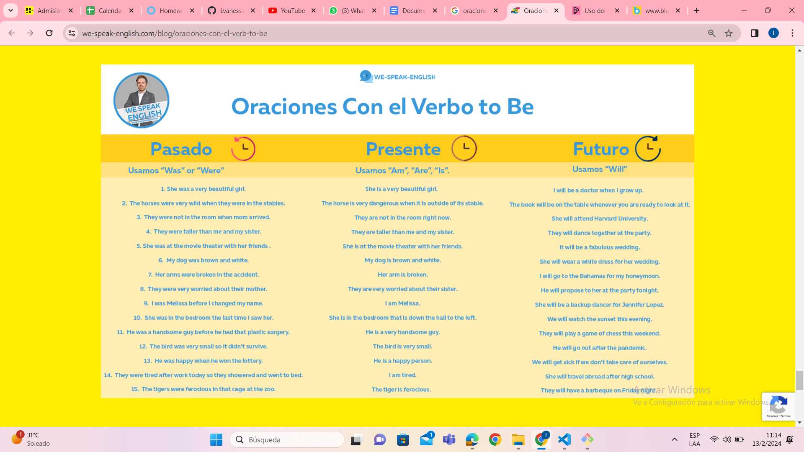



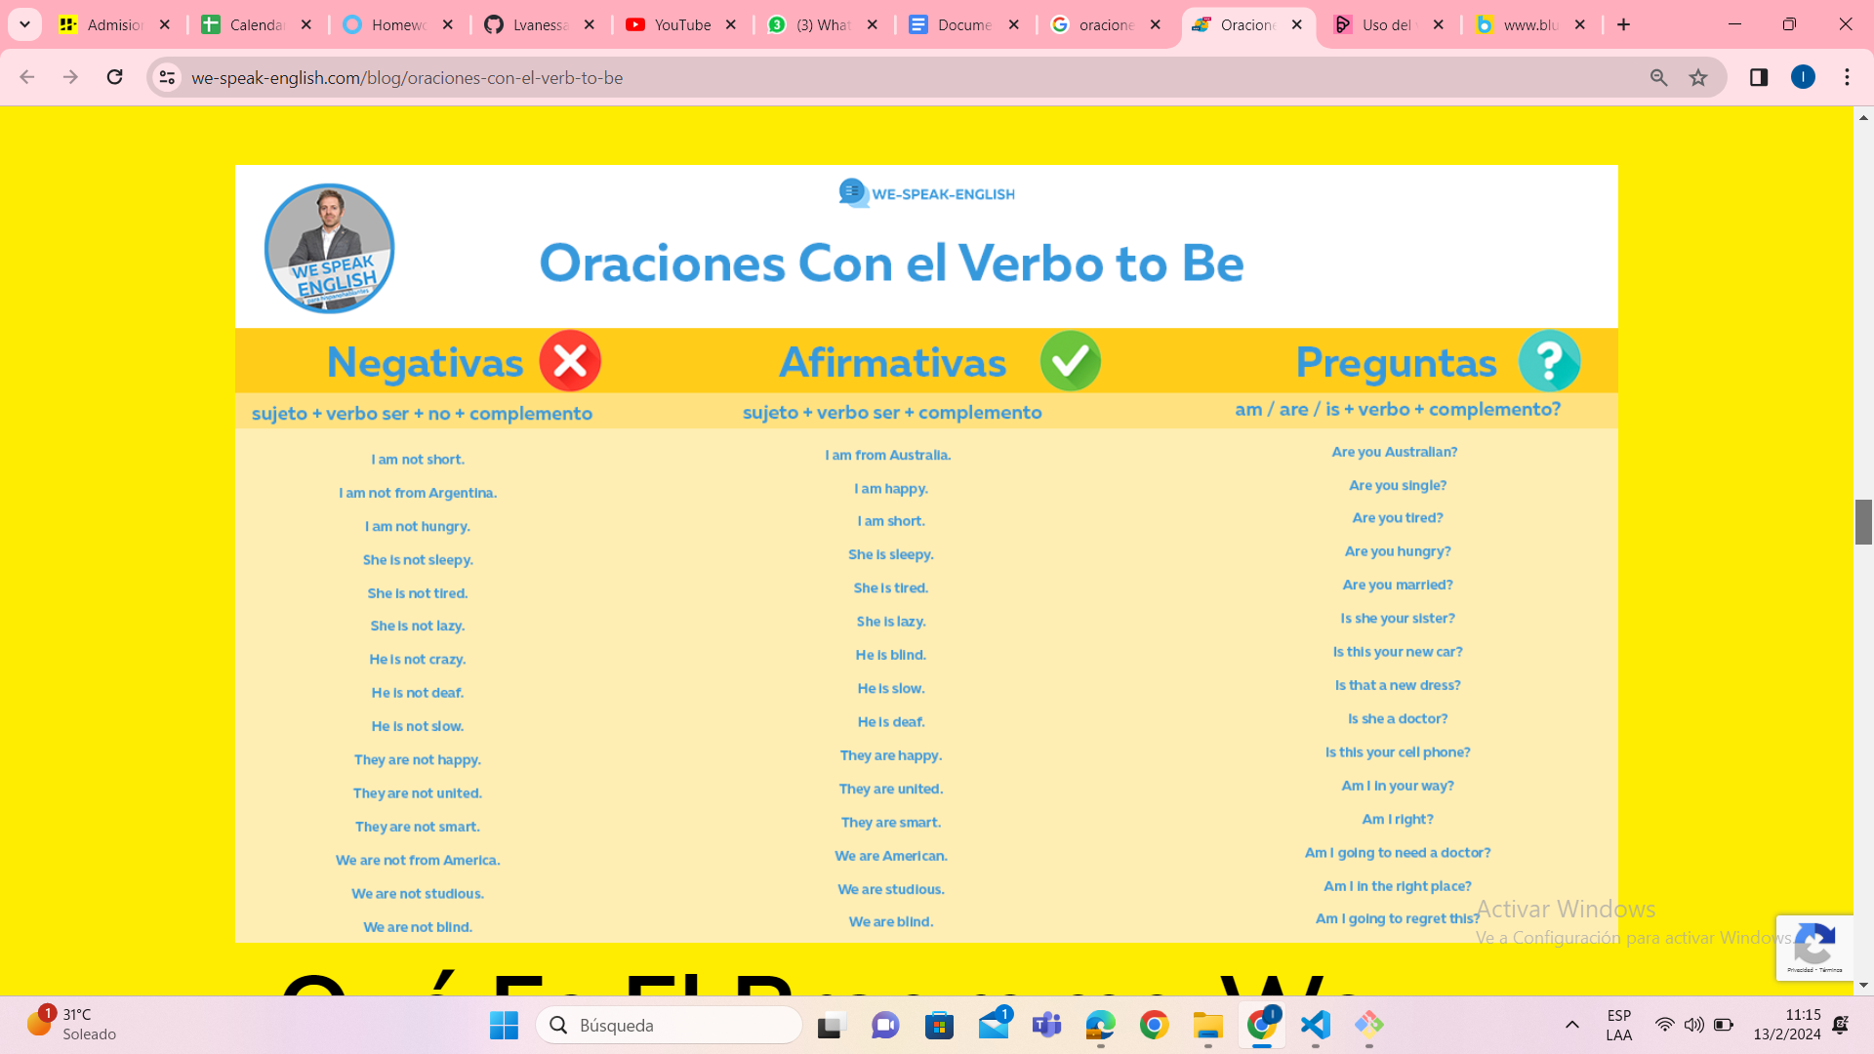

ACTIVIDAD PRÁCTICA DE PRONOMBRES

Analiza qué pronombre existe detrás de los siguientes sujetos.

Ejemplo: 1.-María = she

2.- My brother =

3.-My dog =

4.- Tom and Sue=

5.-Pepe and I =

6. My parents =

7.- The woman =

8.- The boy =

9.- the school =

10.- My classmates and I =

ACTIVIDAD PRÁCTICA VERBO TO BE - PRESENTE SIMPLE

[Verb to be ( am / is / are ), Present Simple, positive sentences and contractions (eclecticenglish.com)](http://www.eclecticenglish.com/grammar/PresentSimpleToBe1A.html)

[Ejerc. verbos To Be (mansioningles.com)](https://www.mansioningles.com/gram37_ej1.htm)

<https://www.superprof.es/apuntes/idiomas/ingles/gramatica-inglesa/verb-tense/exercises-conditional-simple.html>

<https://www.ejerciciosinglesonline.com/new-exercises/presente-simple-ex1/#google_vignette>

* **PERSONAL PRONOUNS**
* En función del sujeto ( El sujeto recae sobre el verbo) : I, you, he, she, it, we, You, they.
* En función del objeto ( El verbo recae sobre el sujeto):

*Me: A mi - I

* You: A ti - You

*Him: A él - He

*Her: A ella - She

*it: A eso - It

*Us: A nosotros - Our

*You: A ustedes - You

*Them: A ellos. - Their

**Ej: - The fire is burning to me.**

* **I burning the fire**
* **PRONOMBRES POSESIVOS (EN FUNCIÓN DE DETERMINANTE):** My, your, his, her, its, our, your, their.

Ej: **My car** is blue.

MY CAR : Mi carro.

Your car: Tu carro.

Yours cars: Sus carros.

His car: Su carro (De él)

Her car: Su carro (De ella)

Its name: Su nombre (De eso)

Our cars: Nuestros carros.

Their car: Su carro ( De ellos)

* **PRONOMBRES POSESIVOS (EN FUNCIÓN DE PRONOMBRE):**

Funciona como un pronombre en función de complemento directo. Siempre va al final de la oración.

Mine: Mio

Yours: Tuyo

His: Suyo

Hers: Suyo

Its: Su

Ours: Nuestro

Yours: Suyo

Theirs: Suyos de ellos

Ej: The blue car is **mine.**

* **PRONOMBRES DEMOSTRATIVOS.**

SINGULAR ( Distancia)

*THIS: Este (esta - esto) - Algo está cerca

*THAT: Ese ( Aquel - aquello) - Algo que esté lejos o que no ves.

PLURAL (Distancia)

*THESE: Estos (Estos)

* THOSE: Esos (Esas)

This notebook. - These notebooks

That notebook. - Those notebook.

Otros usos:

This: Para presentarte por teléfono, para presentar personas.

That: Para referirte a algo que no ves, para referirte a algo del pasado.

* **PRONOMBRES REFLEXIVOS**

Los pronombres reflexivos se usan cuando el sujeto y el complemento del verbo son lo mismo.

* Myself: A mi mismo - I.
* Yourself: A ti mismo - You
* Himself: A él mismo.
* Herself: A ella misma.
* itself: A sí mismo.
* Ourselves: A nosotros mismos.
* Yourselves: A ustedes mismos
* Themselves: A ellos mismos.

*Myself: I watch tv by myselft

* Yourself:

*Himself:

*Herself:

*itself:

*Ourselves:

*Yourselves:

*Themselves:

SELF: SINGULAR

SELVES PLURALES.

Tienden a modificar el significado de algunos verbos por ejemplo: Help.

I teached herself a class.

Presente simple - Verb DO

DO: I, you, we, they

DOES: She, he it.